Project Documentation: Spotify Data Pipeline using Snowflake, AWS, Python, and Lambda
1. Introduction
This project demonstrates how to build a modern ETL pipeline that ingests Spotify data into Snowflake, using AWS S3 for storage, Python for extraction, and AWS Lambda for automation and transformation. The pipeline is serverless, scalable, and near real-time, leveraging Snowpipe auto-ingest for continuous ingestion.
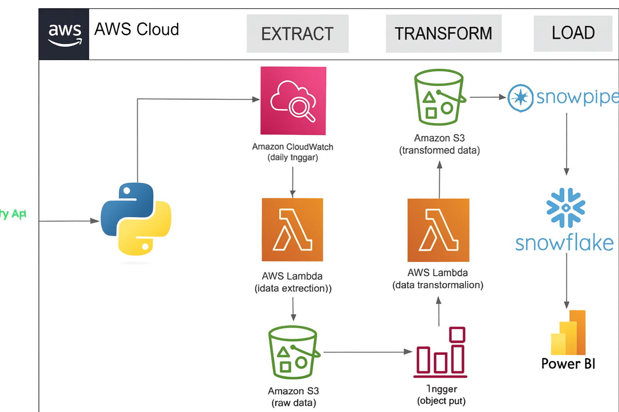
2. Architecture Overview
Flow of Data:
- Extract (Python + Lambda)
  - Python scripts fetch data from the Spotify API.
  - AWS Lambda functions orchestrate the extraction process, ensuring automation without manual triggers.
  - Raw JSON files are generated and stored in S3 under raw_data/.
- Transform (Lambda)
  - A separate Lambda function processes raw JSON files.
  - Converts JSON into CSV format for easier ingestion into Snowflake.
  - Transformed files are stored in dedicated S3 folders (transformed_data/album_data/, artist_data/, songs_data/).
3. Load (AWS S3 → Snowflake)
  - Snowflake external stages connect to the S3 bucket.
  - File formats are defined for CSV ingestion.
  - Snowpipe auto-ingest pipelines load data into structured tables.
- Query & Analytics
- Data is available in relational tables (album_data, artist_data, songs_data).
- Analysts can run queries for insights such as top songs, artist trends, or album releases.

3. Key Components
Python
- Handles Spotify API authentication and data extraction.
- Generates raw JSON files for ingestion.
AWS Lambda
- Extraction Lambda: Automates the Spotify API calls and stores raw JSON in S3.
- Transformation Lambda: Converts raw JSON into CSV format and organizes files into separate folders for albums, artists, and songs.
- Ensures modularity and separation of concerns (one Lambda for raw ingestion, another for transformation).
AWS S3
- Acts as the landing zone for both raw and transformed data.
- Organized into prefixes for raw and transformed datasets.
- Integrated with Snowflake via storage integration.
Snowflake
- Tables: Structured schemas for albums, artists, and songs.
- Stages: External stage pointing to the S3 bucket.
- Snowpipe: Auto-ingest pipelines scoped to specific folders.
- Monitoring: System functions and ingestion history used to track pipeline health.
Code:
create or replace table manage_db.external_stages.album_data(
album_id STRING,
name STRING,
release_date date,
total_tracks int,
url string
);

CREATE OR REPLACE TABLE manage_db.external_stages.artist_data (
artist_id STRING, -- Spotify artist unique ID
artist_name STRING, -- Human-readable name
external_url STRING -- API or Spotify link
);

CREATE OR REPLACE TABLE manage_db.external_stages.songs_data (
song_id STRING, -- Spotify track unique ID
song_name STRING, -- Track name
duration_ms INT, -- Duration in milliseconds
url STRING, -- Spotify track URL
popularity INT, -- Popularity score (0–100)
song_added TIMESTAMP_NTZ,-- When the song was added (no timezone)
album_id STRING, -- Foreign key to album_data
artist_id STRING -- Foreign key to artist_data
);
CREATE OR REPLACE FILE FORMAT manage_db.file_formats.my_csv_file_format
TYPE = 'CSV'
FIELD_DELIMITER = ','
SKIP_HEADER = 1
FIELD_OPTIONALLY_ENCLOSED_BY = '"'
NULL_IF = ('NULL', 'null')
EMPTY_FIELD_AS_NULL = TRUE
ENCODING = 'UTF8';

create or replace stage MANAGE_DB.EXTERNAL_STAGES.CSV_FOLDER
URL='s3://spotify-etl-project-roshan'
STORAGE_INTEGRATION= s3_init
FILE_FORMAT=manage_db.file_formats.my_csv_file_format

DESC INTEGRATION S3_INIT;

LIST @MANAGE_DB.EXTERNAL_STAGES.CSV_FOLDER;

CREATE OR REPLACE schema MANAGE_DB.pipes;

create or replace pipe MANAGE_DB.pipes.album_data
auto_ingest= TRUE
AS
COPY INTO manage_db.external_stages.album_data
FROM @MANAGE_DB.EXTERNAL_STAGES.CSV_FOLDER/transformed_data/album_data/;

ALTER PIPE manage_db.pipes.album_data REFRESH;

desc pipe MANAGE_DB.pipes.album_data;

select * from manage_db.external_stages.album_data;

create or replace pipe MANAGE_DB.pipes.artist_data
auto_ingest= TRUE
AS
COPY INTO manage_db.external_stages.artist_data
FROM @MANAGE_DB.EXTERNAL_STAGES.CSV_FOLDER/transformed_data/artist_data/;
ALTER PIPE manage_db.pipes.artist_data REFRESH;
select * from manage_db.external_stages.artist_data;

desc pipe MANAGE_DB.pipes.artist_data;

select * from manage_db.external_stages.artist_data;

create or replace pipe MANAGE_DB.pipes.songs_data
auto_ingest= TRUE
AS
COPY INTO manage_db.external_stages.songs_data
FROM @MANAGE_DB.EXTERNAL_STAGES.CSV_FOLDER/transformed_data/songs_data/;

ALTER PIPE manage_db.pipes.songs_data REFRESH;
select * from manage_db.external_stages.songs_data;
desc pipe MANAGE_DB.pipes.songs_data;

4. Workflow
- Data Extraction
  - Lambda triggers Python scripts to fetch data from Spotify API.
  - Raw JSON files are stored in S3 (raw_data/).
- Data Transformation
  - A separate Lambda function converts JSON into CSV.
  - Files are organized into transformed_data/album_data/, artist_data/, and songs_data/.
• Data Loading
  - Snowflake stage points to the transformed S3 folders.
  - Snowpipe pipelines ingest CSV into structured tables.
- Data Consumption
- Queries can be run directly on Snowflake tables.
- Example insights:
- Most popular songs per artist
- Albums released by year
- Trends in track popularity
5. Learnings
- How to integrate Snowflake with AWS S3 using storage integrations.
- Automating workflows with AWS Lambda for both extraction and transformation.
- Handling JSON to CSV conversion for schema alignment.
- Monitoring ingestion with Snowflake system functions.
- Exploring advanced Snowflake features like Time Travel, Zero Copy Cloning, and Data Sharing.
6. Outcome
- Raw Spotify JSON data is automatically extracted and stored in S3.
- Transformation Lambda converts JSON into CSV and organizes files by dataset type.
- Snowpipe pipelines ingest CSV into Snowflake tables in real time.
- The pipeline is modular, automated, and production-ready.
- Demonstrates how Python, AWS Lambda, AWS S3, and Snowflake can be combined to build modern, serverless data engineering solutions.

7. Conclusion
This project was not just about building a pipeline — it was about learning Snowflake deeply and applying those concepts alongside AWS services. By combining Python for extraction, Lambda for automation and transformation, S3 for storage, and Snowflake for ingestion and analytics, I created a workflow that transforms raw API data into meaningful insights in real time.

